**Tower Smash**

1. Delete Sprite 1 (the cat).
2. Paint the following backdrop as a bitmap graphic.

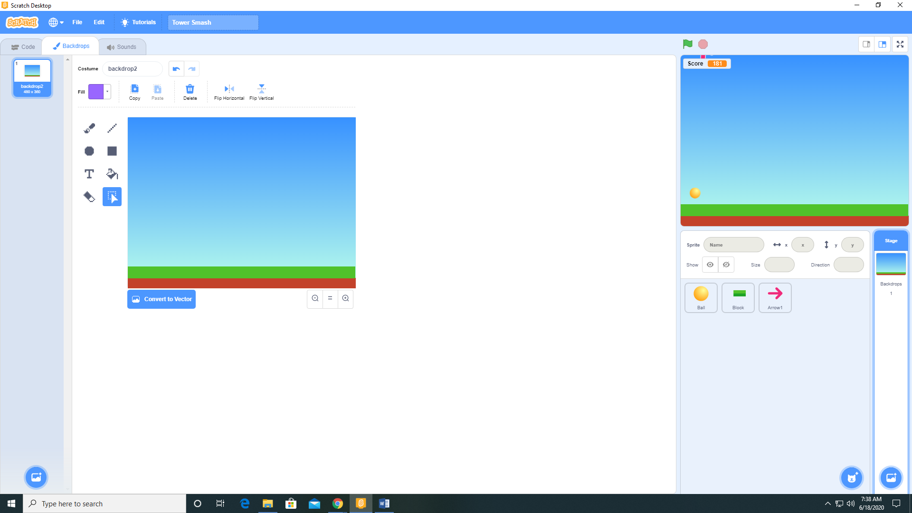

1. Add the variables Hgap, Hspeed, Vgap, Vspeed, Blockcount, Launches, and Score available to all sprites with Scores visible to stage.
2. Add the Ball sprite from the sprite library.
3. Create a MoveBallToStart function for the Ball sprite

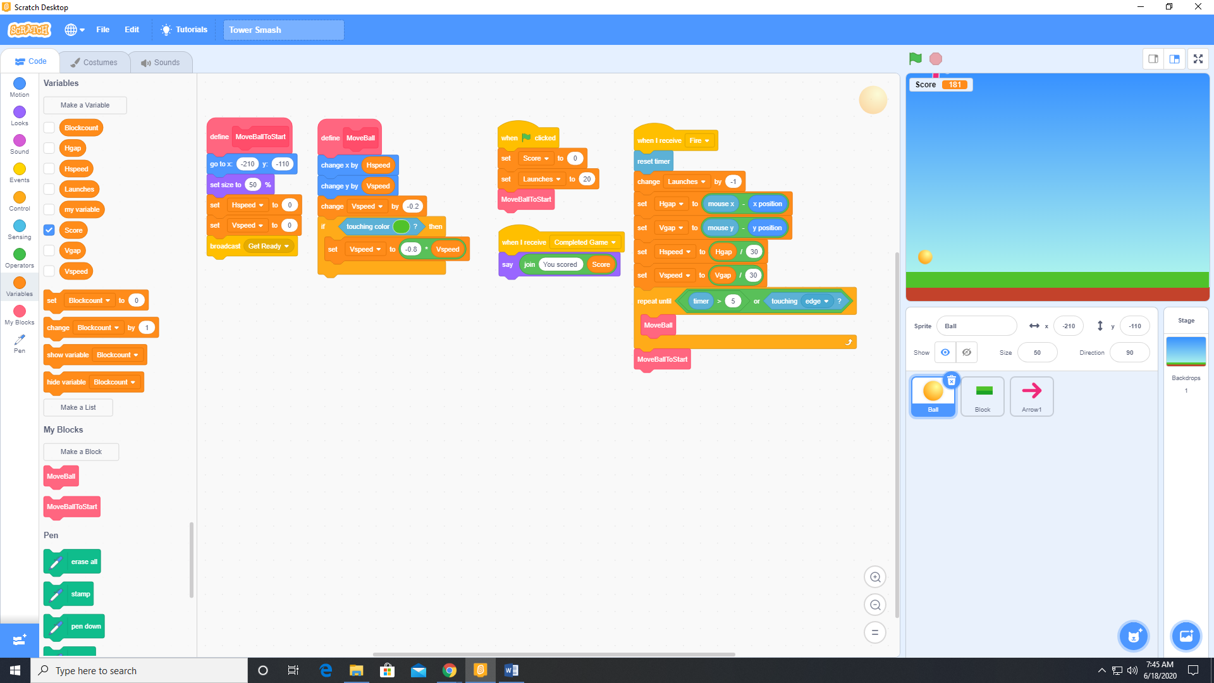

1. Create a MoveBall function for the Ball sprite

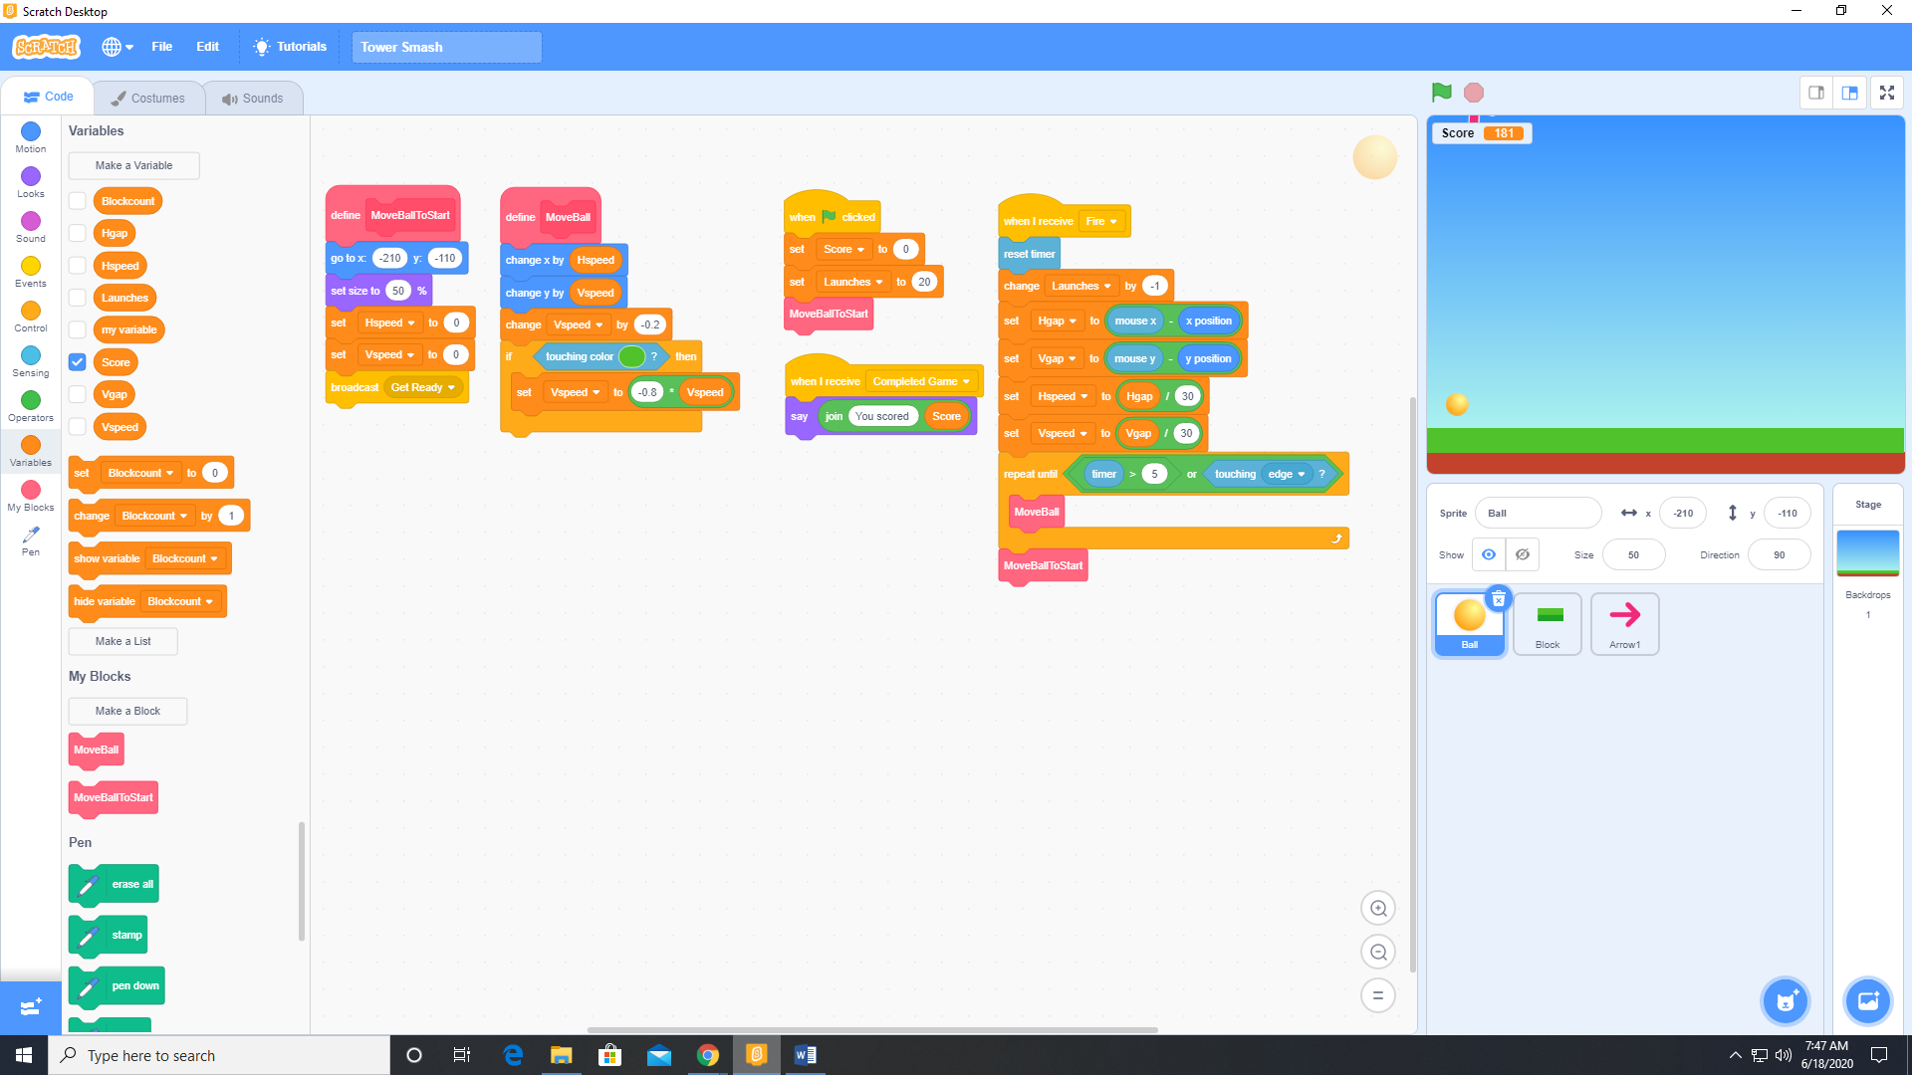

1. Paint a sprite Block as a bitmap graphic. Make sure the top part of the block is the same color as the grass in the backdrop.

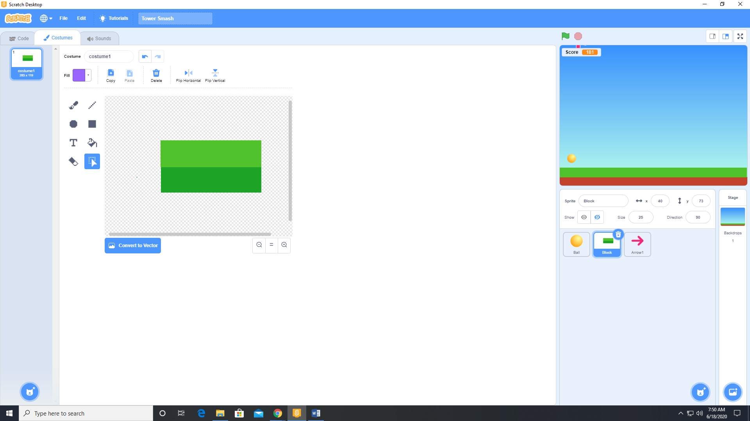

1. Create a CreatePile function for the Block sprite.

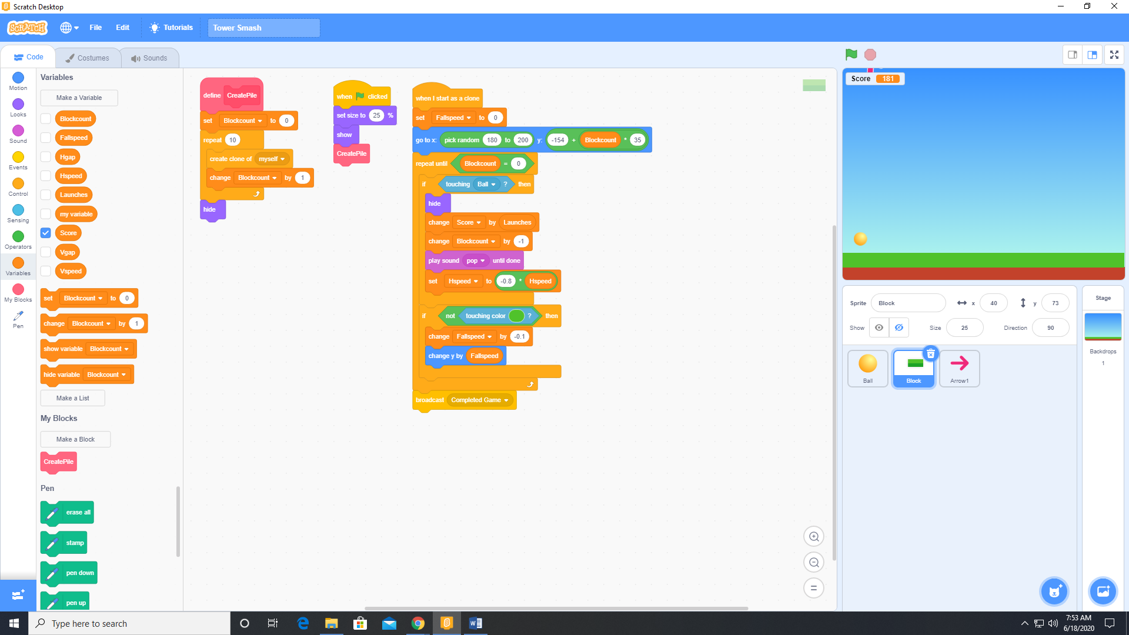

1. Add the following code to the Block sprite.



1. Add a sprite (Arrow 1) from the sprite library.
2. Add the following code to the Arrow 1 sprite.

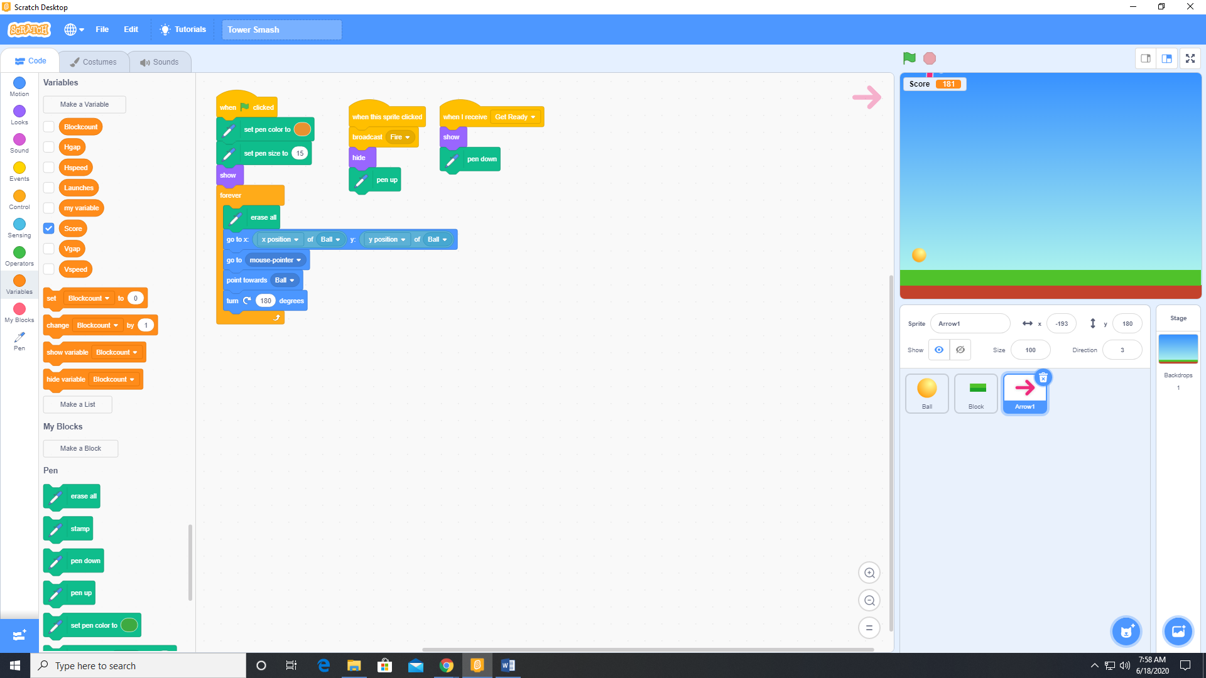

1. Add the following code to the Ball sprite.

